**COMPUTER SCIENCE DEPARTMENT**

LAB: Database System

**Assignment # 04**

**Last date of Submission: 25th October 2024**

# Submitted To: Mam Kashia Riaz

**Student Name: UBAID-BIN-WARIS**

# Reg. Number: 2212416

# 

**Q no.1**

Write an SQL statement to create a simple table countries including columns countary_id, countary_name and region_id.

**Solution**

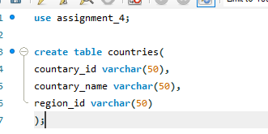

**Q no.2**

Write an SQL statement to create a simple table countries including columns countary_id, countary_name and region_id Which is already exists.

**Solution**

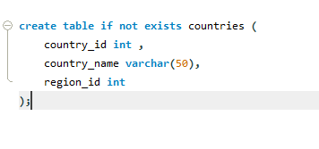



**Q no.3**

Write an SQL statement to create the structure of the table dup_countries similar to countries.

**Solution**

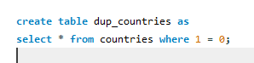

**Q no.4**

Write an SQL statement to create a dublicate copy of countries table including structure and data by namedup_countries.

**Solution**



**Q no.5**

Write an SQL statement to create a table countries with constraint NULL

**Solution**

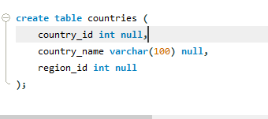

**Q no.6**

Write an SQL statement to create a table named jobs including columns job_id, job_title, min_salary, max_salary, and cheak weather the max_salary exccding the upper limit 25000.

**Solution**

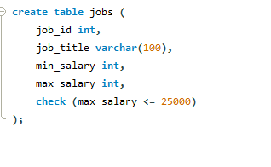

**Q no.7**

Write an SQL statement to create a table named countries including columns countary_id, countary_name and region_id and make sure that there is no country expect Italy, India and China will be entered in a table.

**Solution**

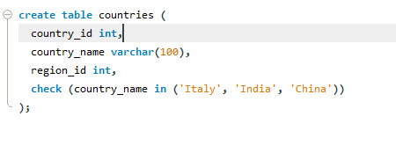

**Q no.8**

Write an SQL statement to create a table named jobs including columns employee_id, start_date, end_date, job_id, department_id and make sure that the value against column end_date will be entered at the time of insertion to the format like ‘--/--/----’

**Solution**

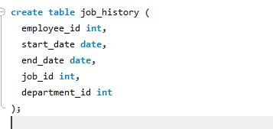

**Q no.9**

Write an SQL statement to create a table named countries including columns countary_id, countary_name and region_id and make sure that there no dublicate data against column countary_id will be allowed at the time of insertion.

**Solution**

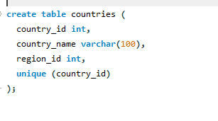

**Q no.10**

Write an SQL statement to create a table named jobs including columns job_id, job_title, min_salary, max_salary, and make sure that, the default value for job_title is blank and min_salary is 8000 and max_salary is NULL will be entered autometically at the time of insertion if no value assigned for the specific columns.

**Solution**

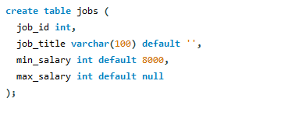

**Q no.11**

Write an SQL statement to create a table named countries including columns countary_id, countary_name and region_id and make sure that the countary_id column will be a key field which will not contain any dublicate data at the time of insertion.

**Solution**

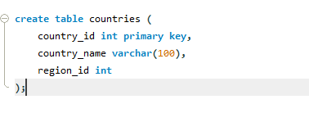

**Q no.12**

Write an SQL statement to create a table named countries including columns countary_id, countary_name and region_id and make sure that the countary_id column will be a unique and store an auto incremented value.

**Solution**

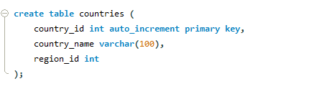

**Q no.13**

Write an SQL statement to create a table named countries including columns countary_id, countary_name and region_id and make sure that the column combination of countary_id and region_id will be unique.

**Solution**

